# Measuring UV screening of the chloroplasts in leaves and algae

## Introduction

For protection against the detrimental action of UV radiation plants are using UV absorbing compounds which are located primarily in external tissues such as the epidermis of leaves. There they act as filters protecting the sensible targets of UV radiation in the tissues below. The extent of this protection is strongly dependent on environmental conditions (Pescheck & Bilger 2020), especially exposure to UV-B radiation, high light and low temperature, but also nitrogen deficiency and high CO2 concentrations enhance the formation of UV screening compounds. In addition, screening may change during the development of leaves. Therefore, it is a priori unclear if two different leaves of the same species display also the same UV protection. However, for the reproducibility of experiments testing the UV sensitivity of plants, it is important to know the amount of radiation absorbed in the epidermis before it can damage sensitive targets within the leaf. On the other hand, the effects of the environment on the accumulation of screening pigments can be much easier studied, when the latter can be determined in intact plant leaves.

First determinations of the depth to which UV radiation penetrates into a leaf were accomplished using fine quartz fibres, which were slowly led through a leaf (Bornman and Vogelmann 1988). This technique is very elaborate, requiring e.g. a precise measurement of the depth of penetration, such that only very laboratories of the world were able to apply it. Furthermore, the technique is destructive and requires rather stable research objects. It cannot be used with mosses or algae.

These drawbacks are avoided by a technique, which uses chlorophyll fluorescence excitation by a UV measuring beam (Bilger et al. 1997). Based on the measuring principle described below, several commercially available devices were developed, of which the Dualex Scientific manufactured by Force A (France) in various versions was the most popular in the last years.

## Measuring principle

The measuring principle of all devices basing on chlorophyll fluorescence excitation depends on two preconditions. First, the chlorophyll fluorescence intensity is proportional to the irradiance absorbed by the chlorophyll and a yield factor, which is dependent on the state of photosystem II. ~~(To be correct, also the state of PS I may have a certain influence. This is, however, only relevant at high excitation densities, which are not used here. Therefore, PS I fluorescence contributes with a constant fraction to the fluorescence intensity.)~~ As long as the electrons transferred by PSII to the primary acceptor QA do not accumulate there, the yield factor remains constant. This is the case when the light received by PS II is sufficiently low. Then, the fluorescence intensity is dependent only on the number of quanta reaching the chloroplasts.

Second, chlorophyll must absorb UV radiation. This is indeed the case, as absorption spectra of chlorophyll *a* and *b* reveal (Fig. 1). Given these facts, the fluorescence yield of a (UV) measuring beam depends on the fraction of it that reaches chloroplasts. In higher plant leaves, the measuring beam must pass the epidermis, which is largely free of chloroplasts, before chlorophyll fluorescence can be excited. Hence, UV absorbing compounds located in epidermal vacuoles or cell walls will affect fluorescence emission. In lower plants, such as ferns and algae, UV absorbing compounds located in external cell walls can fulfil this function (e.g., Pescheck et al. 2014). Since fluorescence emission is also affected by independent factors such as the measuring geometry, the amount of chlorophyll in the leaves, scattering properties of the anatomical structure of the leaves, or in some measuring arrangements simply by the sample size, a reference beam is used which is similarly affected by these factors but not absorbed by screening pigments. In the early measuring apparatus, a blue reference beam was used (Bilger et al. 1997, 2001), since it was assumed that at this wavelength scattering within the leaf would be most similar to the scattering of the UV measuring beam. Later it was recognized that the fluorescence yield of a blue beam is dependent on the amount of the xanthophyll cycle carotenoids in the chloroplasts (Pfündel et al. 2007, Nichelmann et al. 2016), and a red reference beam is used nowadays. Fig. 2 shows a scheme of the measuring principle. Both excitation beams have to pass the epidermis. UV absorbing pigments in the epidermis reduce the intensity of the UV beam, whereas this is not the case for the red reference beam. The latter as well as the emitted chlorophyll fluorescence will not be absorbed in the epidermis and be similarly scattered by it.

## Calculating UV transmittance

The ratio of the UV-induced fluorescence to the red-induced fluorescence (F(UV) / F(R)) is also dependent on the intensities of the measuring beams. In order to calculate a transmittance of the UV beam, it is necessary to know F(UV) / F(R) induced in the absence of any absorbing pigments with identical measuring beam intensities. For most investigated plants, such a state cannot be reached easily. Therefore, various approaches have been used to come as close as possible to such a reference value for 100% transmittance. In our hands, *Epipremnum aureum* growing in a room far away from a window showed 100% UV-A transmittance and high UV-B transmittance on the adaxial leaf side. However, such high transmittances are extremely exceptional. In the vast majority of plant species, it would be necessary to remove the epidermis, which again is not possible in most plants. However, there exist species where at least the abaxial epidermis can be removed, and in some cases, this is even possible with the adaxial epidermis. Especially plants with succulent or at least slightly succulent leaves are amenable. To these plants belong many species from the family Crassulaceae, but also *Vicia faba*, *Pisum sativum* and *Viola tricolor*. Primary leaves from grasses, such as *Hordeum vulgare*, proved successful for peeling the epidermis. At growth conditions strongly inducing the formation of screening compounds, these may accumulate also in mesophyll cells (Agati et al. 2011). Therefore, shade acclimated leaves grown at optimal temperatures should be used for the 100% transmittance standard.

When using Poaceae, one has to bear in mind that these often contain ferulic acid derivatives in their cell walls (Harris and Hartley 1980). Hence, removing the epidermis of species from this family may not remove all UV, especially UV-B, protection (see also Fig. 3). Besides cell wall located absorbing compounds, also scattering properties of the mesophyll cells and potentially the chlorophyll *a*/*b* ratio may affect the F(UV) / F(R) ratio. These and other still unknown factors may contribute to the observed variability of the F(UV) /F(R) ratios from epidermis free leaves of different species, even when selecting leaves from non-inducing conditions. This is demonstrated in Fig. 3, which shows data for F(UV) / F(BG) ratios from epidermis free leaves of various species, plotted against the same ratios obtained with intact leaves. The lower the fluorescence ratio of the intact leaf was, the lower was also the ratio of the epidermis free leaf. In addition, also the maximal fluorescence ratios of the epidermis free leaves vary among the different species. Since one is forced quite often to use the reference ratio from a different species for the investigated species, some caution is necessary in the interpretation of the absolute transmittance values calculated. An uncertainty of about 10% transmittance due to an inappropriate reference value must be accepted. As an alternative, it is possible to use isolated chloroplasts as reference. In these cases, chloroplasts should be applied to a filter paper or a glass fibre filter in a concentration sufficiently high to mimic the chlorophyll content per leaf area in the investigated species (Bilger et al. 1997, Nichelmann et al. 2017). This approach is needed, e.g., when algae or ferns are investigated (Pescheck et al. 2014).

In the most popular device, the Dualex Scientific instrument, the reference value of F(UV) / F(R) for 100% transmittance has been set at the factory and cannot be changed afterwards. Unfortunately, this value may vary among different instruments, as evidenced recently in an instrument intercomparison.

## Advantages of the non-destructive measurements

Using the available portable devices rapid measurements are possible characterizing the photoprotection of leaves as well as their content of protective compounds. For the former trait, the expression as transmittance of the protective tissue/layer is most helpful. Transmittance characterizes the percentage of incident damaging radiation that reaches the chloroplasts. These contain one the most prominent targets of UV-A and UV-B radiation, the water-splitting complex of PS II (Hakala et al. 2005). With this information, it is even possible to compare after an experimental UV exposure the inflicted damage with the amount of radiation reaching the target. This calculation has been used to show that the basic sensitivity of PS II was not different in macroalgae species containing or lacking screening compounds in their cell walls (Pescheck et al. 2014).

From transmittance, absorbance can be calculated, which according to the Lambert-Beer law is proportional to the concentration of absorbing compounds. Hence, what has been called the log fluorescence excitation ratio (log FER; Goulas et al 2004) can be used as a proxy for the amount of UV absorbing pigments in the epidermis. Since the Dualex instrument uses an LED emitting in the UV-A spectral region, where preferentially flavonoids are absorbing, the absorbance parameter calculated by the instrument at this wavelength was termed “Flav value”. However, one should be aware that each UV-absorbing compound adds to the total screening according its own extinction coefficient, which may strongly vary among different compounds. Therefore, the true concentration of specific compounds in the protective layer cannot be simply inferred without further wet chemical analysis. Although usage of the term Flav suggests that (mainly) flavonoids may be responsible for the screening at 365-375 nm, it is also possible that solely hydroxycinnamic acids are used as photoprotectants in this spectral region. For sunflower (*Helianthus annuus* L.) it was shown that the leaves contain only trace amounts of flavonoids and the screening is solely due to chlorogenic acid and its derivatives (Stelzner et al. 2019), which have their spectral absorbance maximum at 330 nm and display only residual absorption around 365 nm. Accordingly, these compounds must have a much higher concentration to reach the same UV-A protection than a flavonoid such as, e.g., quercetin derivatives.

The non-destructive nature of the measurements allows the repeated observation the identical leaf. This allows following the acclimation kinetics of leaves after a change in specific environmental conditions. This is extremely helpful in investigating signal transduction pathways and the evaluation of various environmental conditions, which may trigger the biosynthesis, and accumulation of protective compounds.

The ease of measurements and the portability of the devices allows extensive measurements under natural conditions. E.g., the UV-A-PAM-fluorometer (Gademann Instruments, Germany) has been used to follow protection against natural gradients in UV-B radiation (Barnes et al. 2015). Solanki et al. (2019) observed the time course of UV screening over a year in leaves of *Vaccinium vitis-ideae*.

## Additional parameters

The measuring wavelength can be adjusted to the absorption spectra of the compounds of interest. With the advent of the availability of LEDs emitting in the UV-B, it has become possible manufacturing instruments capable to measure epidermal transmittance around 310 nm. At this wavelength region, both, hydroxycinnamic acid derivatives and flavonoids absorb radiation. Furthermore, at this wavelength the damaging potential of UV radiation is even larger and the determination of protection is closer to the most important stress factor.

When using green light for the measuring beam, anthocyanins can be addressed, which have an absorption maximum in this wavelength region and which serve as photoprotectants in the PAR (Gould 2004, Nichelmann et al. 2017, Pfündel et al. 2007). Applying this rationale, the Dualex Scientific instrument provides also an anthocyanin index. However, this index needs to be considered with caution. Absorptance of a leaf in the green spectral region is much lower than in the red region. Therefore, decreases in chlorophyll content will first affect absorptance and, hence, fluorescence excitation, in the green region, before the absorptance of the red reference beam is affected. With decreasing chlorophyll content, the excitation ratio F(green) / F(red) will decline even in the absence of anthocyanins (see Nichelmann et al. 2017). In principle, the same considerations should apply also for the UV spectral region, since there absorbance of chlorophyll is lower than at the absorbance peak in the red. However, the difference in absorbance to the red region is much lower for UV than for green light. Therefore, F(UV) / F(red) should be much less affected by changes in chlorophyll content than F(green) / F(red).

In the blue wavelength region, carotenoids located in the pigment protein complexes in the thylakoid membrane of the chloroplasts compete with chlorophyll for excitation energy. Whereas lutein and neoxanthin transfer almost 100% the absorbed excitation to chlorophyll, -carotene is much less efficient (around 30%) and violaxanthin and its de-epoxidation products antheraxanthin and zeaxanthin are entirely unable to transfer energy to chlorophyll (Caffari et al. 2001). The latter pigments show an enhanced content in chloroplasts relative to chlorophyll when plants are growing at high light (Thayer & Björkman 1989). This enhancement can be as high as a factor of 5, when plants grown in full sunlight are compared to plants grown in deep shade. Hence, the relative absorption of blue light by the pigments of the violaxanthin cycle and the according loss of excitation energy for chlorophyll will increase in high light grown leaves. Accordingly, the relative excitation efficiency at around 470 nm can be used as an indicator of the pool size of the violaxanthin cycle pigments (Nichelmann et al 2016). Recently, it has been shown in leaves of rocket (*Diplotaxis tenuifolia*), that the excitation efficiency at 470 nm follows also the dynamic changes in carotenoid content in single leaves when these are exposed to changes in irradiance (Khoramizadeh et al. 2024). It needs to pointed out, that at this wavelength range only a relative excitation efficiency can be determined, which cannot be described in terms of transmittance. Nevertheless, comparison to the maximal excitation efficiency observed in shade acclimated leaves is possible and relative trends can be deduced. With the LSA-2050 device (Walz GmbH, Germany), which contains also an LED for excitation at 450 nm, such measurements have become recently easily possible.

In addition to the pigment detection using chlorophyll fluorescence, the available devices use also measurements of transmittance through the leaves to quantify chlorophyll content. For this purpose, a wavelength absorbed by chlorophyll and one that is too long to be absorbed by chlorophyll are used. The latter serves as a reference, allowing correction for non-specific scattering properties of the leaves. It has proven advantageous to use a wavelength at the long wavelength tail of the chlorophyll absorption spectrum, which enhances the linear range of the relationship between absorbance and pigment content (Cerovic et al. 2012).

A further helpful information for field measurements is the use of a GPS sensor for locating the measured leaf. Using this technique allowed to map the pigment contents of grapevine leaves and use this information to draw a map of nutrient requirements in the respective vineyard (Cerovic….) .

Recently, also sensors for leaf orientation and angle were included in a device, which combined with data on the date and location makes it possible to deduce the relative sun exposure of the investigated leaf.

## Precautions and pitfalls

When using chlorophyll fluorescence for assessing the function of PS II, the short-term pre-illumination history and the simultaneous irradiation of the leaf are of utmost importance. For the measurement of epidermal transmittance, necessary precautions are much less severe. Since after darkening of a leaf rapid changes of the fluorescence are finished after a few minutes, measurements with devices, which use a sequential irradiation of the sample with the different measuring beams, can be accomplished without problem 2 min after darkening a leaf. With devices using quasi simultaneous irradiation with all measuring beams such as the Dualex instruments, in principle no dark acclimation of the leaves is needed. This is specifically useful in field investigations.

As is always the case with measuring instruments, calibration of the used devices should be checked. Ideally the device should be sent to the manufacturer in regular time intervals. For a control when a calibration at the manufacturer is needed again, standards can be used to compare the stability of the signals with time. A physical standard could be a plastic foil with fluorescence excitation and emission spectra similar to those of chlorophyll. Helpful are also plants grown under standardized conditions. For example, *Vicia faba*, or any other plant species from which the epidermis can be easily peeled, grown under low irradiance will provide a quite stable reference system. Intercomparison among several devices in regular time intervals is also helpful to detect any changes in the performance of an instrument.

The existence of diel time courses of UV screening in leaves has been demonstrated for several plant species (Barnes et al. 2016). Although these species seem rather an exception, the absence of such short term variations should always be checked. When these are observed, one should be careful before deducing an according rapid metabolisation of the responsible screening pigments.

With its introduction the fluorescence method was coined as a method for the determination of epidermal UV transmittance or epidermal UV screening. However, although the majority of UV protection is achieved by UV absorbing compounds located in the epidermis of leaves (see, e.g., Burchard et al. 2000), a contribution by compounds in the mesophyll cannot be excluded. This has become very obvious when investigating the screening properties of anthocyanins in *Berberis* *thunbergii*, a species in whose leaves the anthocyanins are only located in the mesophyll. Despite this location, screening of up to 50% of integrated solar irradiation was calculated (Nichelmann et al. 2017). After growth at conditions strongly inducing the accumulation of screening pigments, leaves from which the epidermis was removed also showed reduced UV fluorescence excitation efficiency. Hence, also compounds located in vacuoles at the side of chloroplasts may provide light protection, albeit with a lower efficiency than compounds in epidermal vacuoles. Strong light scattering within leaves may one of the mechanisms by which this is achieved.

When leaves with reduced chlorophyll contents are investigated, fluorescence excitation ratios can be affected as already highlighted above. This is especially obvious with fluorescence excitation in the green absorption gap of chlorophyll, but may at further reduced chlorophyll contents also affect UV excitation ratios. Since human vision is especially sensitive in the green spectral region, where anthocyanins have their absorption maximum, human eyes are well equipped to detect anthocyanins in leaves. Hence, if an instrument is indicating the presence of anthocyanins in leaves, which are obviously greenish, further checks of plausibility are strongly recommended.

References

Agati G, Cerovic ZG, Pinelli P, Tattini M (2011) Light-induced accumulation of ortho-dihydroxylated flavonoids as non-destructively monitored by chlorophyll fluorescence excitation techniques. Environ Exp Bot 73: 3-9

Barnes PW, Flint SD, Tobler MA, Ryel RJ (2016) Diurnal adjustment in ultraviolet sunscreen protection is widespread among higher plants. Oecologia 181: 55-63

Barnes PW, Flint SD, Rye RJ, Tobler MA, Barkley AE, Wargent JJ (2015) Rediscovering leaf optical properties: New insights into plant acclimation to solar UV radiation. Plant Physiol Biochem 93: 94-100

Bilger W, Veit M, Schreiber L, Schreiber U (1997) Measurement of leaf epidermal transmittance of UV radiation by chlorophyll fluorescence. Physiol Plant 101: 754-763

Bilger W, Johnsen T, Schreiber U (2001) UV-excited chlorophyll fluorescence as a tool for the assessment of UV-protection by the epidermis of plants. J Exp Bot 52: 2007-2014

Bornman JF, Vogelmann TC (1988) Penetration of blue and UV radiation measured by fiber optics in spruce and fir needles. Physiol Plant 72: 699-705

Burchard P, Bilger W, Weissenböck G (2000) Contribution of hydroxycinnamates and flavonoids to epidermal shielding of UV-A and UV-B radiation in developing rye primary leaves as assessed by UV-induced chlorophyll fluorescence measurements. Plant Cell Environ 23: 1373-1380

Caffarri S, Croce R, Breton J, Bassi R (2001) The major antenna complex of photosystem II has a xanthophyll binding site not involved in light harvesting. J Biol Chem 276: 35924-35933

Cerovic ZG, Masdoumier G, Ben Ghozlen N, Latouche G (2012) A new optical leaf-clip meter for simultaneous non-destructive assessment of leaf chlorophyll and epidermal flavonoids. Physiol Plant 146: 251-260

Goulas Y, Cerovic Z, Cartelat A, Moya I (2004) Dualex: a new instrument for field measurements of epidermal ultraviolet absorbance by chlorophyll flourescence. Appl Opt 43: 4488-4496

Gould KS (2004) Nature's swiss army knife: The diverse protective roles of antocyanins in leaves. J Biomed Biotech 5: 314-320

Hakala M, Tuominen I, Keränen M, Tyystjärvi T, Tyystjärvi E (2005) Evidence for the role of the oxygen-evolving manganese complex in photoinhibition of Photosystem II. Biochim Biophys Acta - Bioenerg 1706: 68-80

Harris PJ, Hartley RD (1980) Phenolic constituents of the cell walls of monocotyledons. Biochem System Ecol 8: 153-160

Khoramizadeh F, Garibay-Hernández A, Mock HP, Bilger W (2024) Improvement of the quality of wild rocket (*Diplotaxis tenuifolia*) with respect to health-related compounds by enhanced growth irradiance. J Agric Food Chem 72: 9735-9745

Nichelmann L, Schulze M, Herppich WB, Bilger W (2016) A simple indicator for non-destructive estimation of the violaxanthin cycle pigment content in leaves. Photosynth Res 128: 183-193

Nichelmann L, Bilger W (2017) Quantification of light screening by anthocyanins in leaves of *Berberis thunbergii*. Planta 246: 1069-1082

Pescheck F, Bilger W (2020) UV-B resistance of plants grown in natural conditions. Ann Plant Rev 3: 337-398

Pescheck F, Lohbeck KT, Roleda MY, Bilger W (2014) UVB-induced DNA and photosystem II damage in two intertidal green macroalgae: Distinct survival strategies in UV-screening and non-screening Chlorophyta. J Photochem Photobiol B-Biol 132: 85-93

Pfündel EE, Ghozlen NB, Meyer S, Cerovic ZG (2007) Investigating UV screening in leaves by two different types of portable UV fluorimeters reveals in vivo screening by anthocyanins and carotenoids. Photosynth Res

Solanki T, Aphalo PJ, Neimane S, Hartikainen SM, Pieriste M, Shapiguzov A, Porcar-Castell A, Atherton J, Heikkila A, Robson TM (2019) UV-screening and springtime recovery of photosynthetic capacity in leaves of *Vaccinium vitis-idaea* above and below the snow pack. Plant Physiol Biochem 134: 40-52

Thayer SS, Björkman O (1990) Leaf xanthophyll content and composition in sun and shade determined by HPLC. Photosynth Res 23: 331-343

Figures

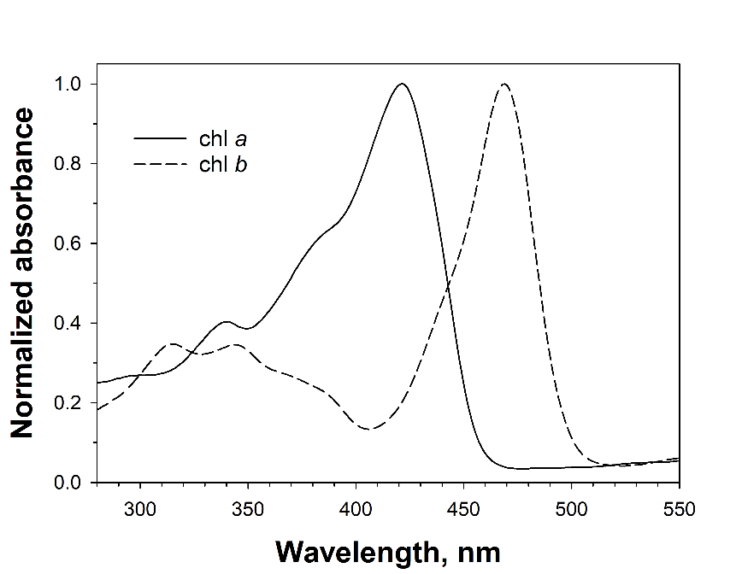

Fig. 1: Normalized absorbance spectra of chlorophyll *a* (isolated from *Asterocapsa nidulans* (N.L. Gardner) Komárek & Komárková-Legnerová) and chlorophyll *b* (purchased from Sigma-Aldrich) in 100% methanol.

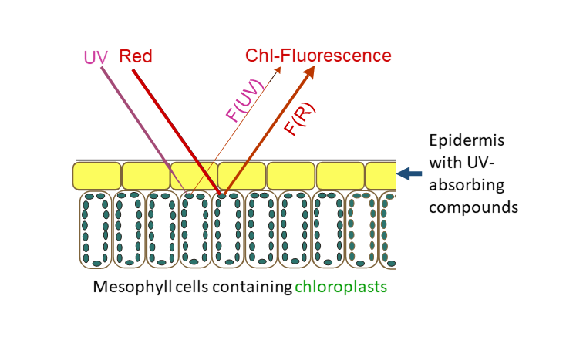

Fig. 2: Schematic illustration of the measuring principle showing the cross section of the upper cells of a leaf. UV-absorbing compounds in the epidermis attenuate the UV excitation beam, whereas the red excitation beam and the chlorophyll fluorescence excited by the two beams are passing the epidermis unhindered. The ratio between UV- and red-excited fluorescence, F(UV) / F(R), is dependent on the amount of UV-absorbing compounds between the leaf surface and the chloroplasts.

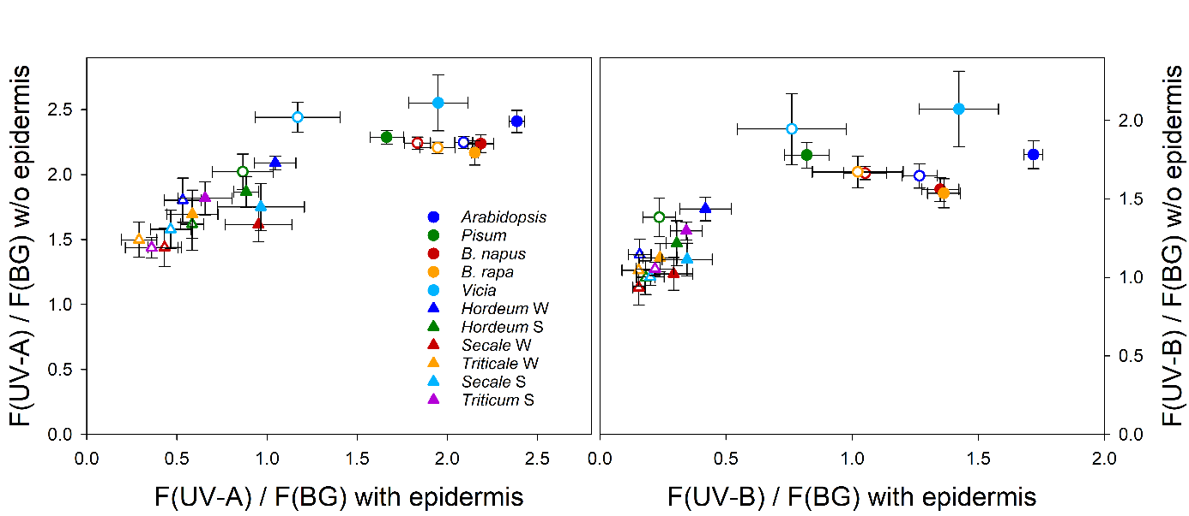

Fig. 3: Fluorescence excitation ratios determined with a Xe-PAM fluorometer (Walz, Effeltrich, Germany; Bilger et al. 1997) from 5 dicotyledoneous species (circles) and 6 varieties from 4 monocotyledoneous species grown from fall 2000 to spring 2001 at Ås, Norway, in a phytotron at 21°C (closed symbols) or at 9°C (open symbols). Excitation ratios using a UV-A beam (left panel) or a UV-B beam (right panel) with reference to a broad blue-green (BG) excitation beam were determined from abaxial sides of leaves before (x-axis) and after (y-axis) removal of the epidermis. The following species and varieties were used: *Arabidopsis thaliana* acc. Columbia, *Pisum sativum* subsp. *sativum* cv. *axiphium, Brassica napus* cv. Bambu, *Brassica rapa* cv. Agneta, *Vicia faba* cv. Witkiem, *Hordeum vulgare* cv. Frost, *H. vulgare* cv. Tyra, *Secale cereale* cv. Danko, *S. cereale* cv. Rogo, *Triticale* cv. Prego, *Triticum* *aestivum* cv. Bastian. Unpublished data by Mari Rolland and Wolfgang Bilger.